**Why choose Drupal & Acquia**

## **Why Drupal?**

Drupal is a Content Management System (CMS) originally developed by Dries Buytaert in 2001. Drupal is an Open Source project that is backed by the Drupal Association organization and has a community of over 100,000 actively contributing members. The Open Source model provides one of the largest communities in the world. Built around the concepts of Linux, Drupal provides a highly extensible framework which emphasizes on security and performance. Drupal 8 is built on top of the Symphony PHP framework which ensures developers are writing highly structured code using Object Oriented Programming (OOP).

This highly extendable framework that’s built on top of an Open Source community has fostered a key advantage of Drupal - contributed modules. Drupal modules are sub-projects built by the contributors of the community which extend Drupal’s functionality into endless features.  
As of today, there are over 42,000 modules available for download. For example, a Single-Sign-On implementation can be provided by almost all 3rd party libraries and modules. In fact, we have done a short study of the code structure of a mid-sized Drupal project for an enterprise client. The final results are pretty astonishing – with custom code only attributing to less than 1% of the total codebase!

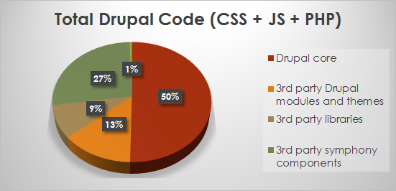

This allows Drupal projects to be--

1. Built quickly - by reusing the many available modules in the Open Source community.
2. Have high quality code - by leveraging publicly built code and limiting custom code to a minimum, the overall quality of the code provides very high standards.
3. Having high cost efficacy - since there is no subscription costs and a lot of code can be leveraged, costs associated with building a Drupal site are much smaller.

## **Comparing Drupal**

When comparing Drupal to a behemoth giant like Adobe Experience Manager (AEM) the differences are staggering. AEM is a all-in-one platform for enterprises. It includes an end-to-end solution which bulks all the features an enterprise might want into a single solution. This sounds great, but this carries a heavy burden.

1. AEM is very expensive.
2. AEM is a proprietary platform thus providing a totalitarian approach; versus Drupal which fosters a Democratic government system of the platform.
3. Drupal is much faster and easier to build than AEM.
4. Drupal provides many more options in terms of features that can be combined from the community and hosting as you are not locked in to the features and server solutions with AEM.



This is why companies like Apigee are choosing Drupal.

1. High Interoperability allowing Drupal to be configured easily with REST.
2. Low cost, fast build times, and ease of development.

Apigee offers a few options for an API Developer portal: a) Drupal 7 configured platform with many out-of-the-box features an organization may need for an API Developer portal. b) Drupal 8 module which lets developers build on top of its functionality to build an API Developer portal that’s right just for you.

## **Choosing a Hosting Service**

The solution of choice for hosting Drupal is Acquia. Drupal is not always free! In order to monetize Drupal, in 2007, the leaders from the Drupal Association including Dries Buytaert himself decided to spin off a company to provide an end-to-end hosting solution for Drupal sites specifically.

This is the key advantage of Acquia that sets them apart from the rest of the hosting solutions. Acquia is a PaaS solution catered specifically to Drupal. This means that all the components that are required for large scale enterprise Drupal projects to run in high scalability environments are provided out-of-the-box. This includes integration with Apache Solr search, HTTP caching, database caching, and performance monitoring all configured by the Acquia Team. Even security patches to your Drupal core code are provided by their support team. No other service is out there like it. On top of the core product offering of cloud services, Acquia has built products which can integrate with your Drupal site to provide functionality like personalization; similar to as AEM offers. This whole product offering has placed Drupal into a solution beyond just a Content Management System (CMS). Acquia Drupal is a Web Content Management (WCM) system which competes with giants like AEM. Acquia Drupal has ranked in the top quadrants of both Gartner and Forrester reports in 2018.

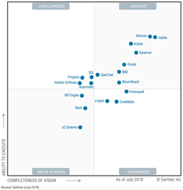 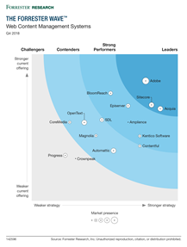

WCM – Gartner 2018 – Magic Quadrant – Acquia Drupal

WCM – Forrester Q4 2018 – Leader – Acquia Drupal